Theoretical, Evidence-informed And Co-designed Health Innovation Teamwork (TEACH-IT)
Joy C MacDermid PhD

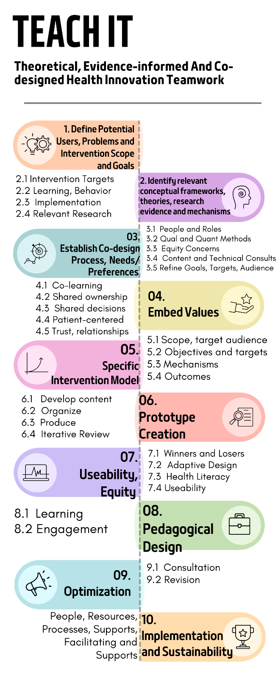
- Define Potential Users, Problems and Intervention Scope and Goals
  - Identify Target Users (Patients and providers)
    - Relationships, patient partners^{1,2}, early adopters, opinion leaders and stakeholders
  - Identify Internal/external Context Factors
  - Identify Gaps to be addressed, Clinical Goals, Scope of Innovation Plan

- Identify relevant conceptual frameworks, theories, research evidence and mechanisms for:
  - Intervention targets (Physical, Psychological, Social Health), Skills, Knowledge and Attitude Targets and related Mechanisms
  - Learning and Behaviour Change Theory(Mechanisms)^{3–5}
  - Pedagogical Theory
  - Implementation Theory
  - Relevant Content from literature (evidence synthesis)

- Establish Co-design Process, Needs/Preferences
  - Engage knowledge user partners and define co-design process and roles^{6–10}.
  - Use qualitative and quantitative methods to define target Users Needs, Preferences and Priorities for content/delivery,
  - Define intersectional equity concerns.
  - Iterative Content and Technical Expert consultations on content, format and learning strategies
  - Refine Therapeutic Goals, Intervention Targets and Target Audience

- Embed Values in Co-design Processes^{11–15}
  - Co-learning to achieve shared understanding
  - Shared ownership
  - Shared decision-making, a voice for all team members
  - Patient-centered
  - Trust and relationship strengthening

- Establish a Specific Intervention Model- Concept mapping^{16,17}, intervention mapping^{18–23} and/or logic models²⁴ to define:
  - Scope and target audience
  - Specific objectives
  - Skills, Knowledge and Attitude Targets.
  - Therapeutic interventions/content and their expected mechanisms.
  - Content/component weighting and organization
  - Process and outcome measures that can monitor uptake and impact.
    - Design an outcome strategy and select indicators/measures.
  - Map intervention components and mechanisms to expected outcomes.
  - Select outcome measures and strategy
    - Adherence, fidelity and process outcomes
    - Quintuple Aims^{25,26}
      - Patient Experience
      - Patient outcomes
      - Providers experience outcomes
      - Costs
      - Equity Outcomes
    - Review measurement properties of potential tools/measures
    - Select and document outcome measurement strategy (measures, timing, delivery, scoring)

- Prototype Creation -Generative Design
  - Prioritize and develop content
  - Designate chunks/modules.
  - Develop scripts, story boards and structural templates.
  - Produce components
  - Obtain iterative expert, user, stakeholder feedback on scripts and produced components.

- Useability^{27–30}, Equity^{31,32} and Inclusion Strategy
  - Define “who might be left behind” and needs of diverse subgroups (equity and clinical experts and target user consultations)
  - Determine capacity and priority for adaptive responsive design features, versions or content to improve equity.
  - Health literacy evaluations and content clarification
  - Useability Analysis (e.g., Observational, cognitive interviews, surveys, qualitative).

- Pedagogical Design³³
  - Design and embed learning strategies and interactivity (e.g., teach-back, audit and feedback, self-tests, community of practice, FAQ).

- Optimization through Revision/ Adaptation
  - Iterative consultation with target audience, experts, users, and other stakeholders to refine.

- Implementation^{34–42} and Sustainability⁴³
  - Develop an implementation plan (e.g., champions, implementation personnel, process, timing), resources (training materials, funding, facilities), sharing principles/rules, strategies (training, incentives, procedures) and monitoring (uptake and use indicators).
  - Evaluate implementation and adapt, including feedback into iterative improvement/optimization.
  - Evaluate impact.
  - Develop and implement sustainability plan.
    - Resources Needs and Plan
    - Personnel Needs and Plan
    - Authorities/Ownership Documentation, Roles, Processes and Management Plan
  - Monitoring and Reporting Plan

Quality standards
The ultimate goal is better quality of health care interventions considering the Quintuple Aims^{25,26} of patient experience and outcomes, provider work role experience, cost efficiency and equity. In interim evaluation of an innovation during development we assess the quality of the content (evidence-based) and the 3U’s of Usability (Useful, Useable, Unbiased).
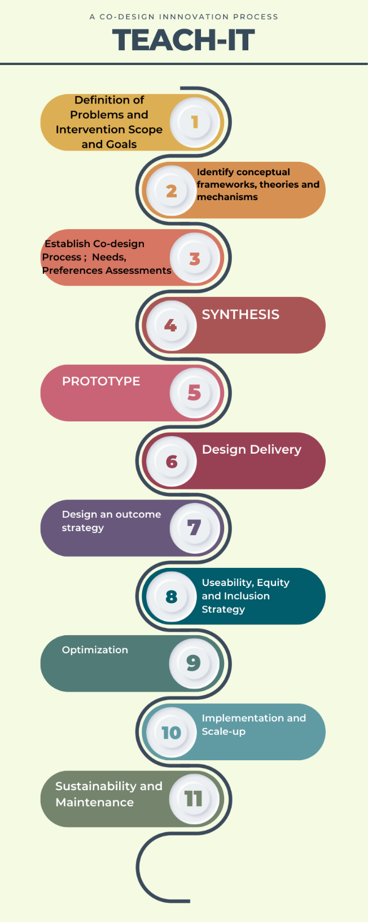
- Quality of Content
  - Theoretical and basic science mechanisms are clear and articulated.
  - Best clinical evidence integrated.
  - Clear user engagement: mapped to end-user needs.

- The 3 Us of Useability
  - Useful
    - Content relevant to users
    - Customizable to individual variation/priorities
    - Perceived benefit to users (potential for impact)
    - Change in health outcomes.
  - Useable
    - Accessible
    - Understandable (literacy and health literacy)
    - Fidelity-implemented/performed efficiently and accurately by different users.
    - Used (adherence)
  - Unbiased
    - Equity, Inclusion and Diversity (considers socioeconomic, regional, cultural, sex/gender, age, and other sources of diversity) in access, approach and content.

Examples of methods for different stages of development:
- Needs and content assessments: consultations, surveys, consensus techniques, qualitative research, patient- clinician expert co-design.
- Best practices or evidence-informed content: evidence synthesis, expert consensus
- Useability: consultations, cognitive interviews, text analysis, observational analysis of use, and user ratings
- Equity - equity assessment/consultation; examination of data using intersectional lens

References
1. Bird M, Ouellette C, Whitmore C, et al. Preparing for patient partnership: A scoping review of patient partner engagement and evaluation in research. Heal Expect. 2020;23(3):523-539. doi:10.1111/hex.13040
2. Mrklas KJ, Boyd JM, Shergill S, et al. Tools for assessing health research partnership outcomes and impacts: a systematic review. Heal Res Policy Syst. 2023;21(1):1-30. doi:10.1186/s12961-022-00937-9
3. Yardley L, Spring BJ, Riper H, et al. Understanding and Promoting Effective Engagement With Digital Behavior Change Interventions. Am J Prev Med. 2016;51(5):833-842. doi:10.1016/j.amepre.2016.06.015
4. Araújo-Soares V, Hankonen N, Presseau J, Rodrigues A, Sniehotta FF. Developing Behavior Change Interventions for Self-Management in Chronic Illness: An Integrative Overview. Eur Psychol. 2019;24(1):7-25. doi:10.1027/1016-9040/a000330
5. Teixeira PJ, Marques MM, Silva MN, et al. A classification of motivation and behavior change techniques used in self-determination theory-based interventions in health contexts. Motiv Sci. 2020;6(4):438-455. doi:10.1037/mot0000172
6. Millard D, Howard Y, Gilbert L, Wills G. Co-design and co-deployment methodologies for innovative m-learning systems. Mult E-Learning Syst Technol Mob Devices Ubiquitous ICT-Based Educ. Published online 2009:147-163. doi:10.4018/978-1-60566-703-4.ch009
7. Jessup RL, Osborne RH, Buchbinder R, Beauchamp A. Using co-design to develop interventions to address health literacy needs in a hospitalised population. BMC Health Serv Res. 2018;18(1):1-13. doi:10.1186/s12913-018-3801-7
8. Castro EM, Malfait S, Van Regenmortel T, Van Hecke A, Sermeus W, Vanhaecht K. Co-design for implementing patient participation in hospital services: A discussion paper. Patient Educ Couns. 2018;101(7):1302-1305. doi:10.1016/j.pec.2018.03.019
9. Spina G, Verganti R, Zotteri G. Factors influencing co-design adoption: Drivers and internal consistency. Int J Oper Prod Manag. 2002;22(12):1354-1366. doi:10.1108/01443570210452048
10. Sumner J, Chong LS, Bundele A, Wei Lim Y. Co-Designing Technology for Aging in Place: A Systematic Review. Gerontologist. 2021;61(7):E395-E409. doi:10.1093/geront/gnaa064
11. Sumner J, Tan SY, Wang Y, et al. Co-Designing Remote Patient Monitoring Technologies for Inpatients: Systematic Review. J Med Internet Res. 2024;26:e58144. doi:10.2196/58144
12. Slattery P, Saeri AK, Bragge P. Research co-design in health: A rapid overview of reviews. Heal Res Policy Syst. 2020;18(1). doi:10.1186/s12961-020-0528-9
13. Peters S, Guccione L, Francis J, et al. Evaluation of research co-design in health: a systematic overview of reviews and development of a framework. Implement Sci . 2024;19(1). doi:10.1186/s13012-024-01394-4
14. Masterson D, Josefsson KA, Robert G, Nylander E, Kjellstrom S. Mapping definitions of co‐production and co‐design in health and social care. Heal Expect. 2022;25(1):902-913.
15. Baker A, Cornwell P, Gustafsson L, Stewart C, Lannin NA. Developing tailored theoretically informed goal-setting interventions for rehabilitation services: a co-design approach. BMC Health Serv Res. 2022;22(1):1-21. doi:10.1186/s12913-022-08047-6
16. Trochim WMKE. Concept Mapping for Evaluation and Planning.PDF. Eval Program Plann. 2006;12:216.
17. Trochim WM, McLinden D. Introduction to a special issue on concept mapping. Eval Program Plann. 2017;60:166-175. doi:10.1016/j.evalprogplan.2016.10.006
18. Direito A, Walsh D, Hinbarji M, et al. Using the Intervention Mapping and Behavioral Intervention Technology Frameworks: Development of an mHealth Intervention for Physical Activity and Sedentary Behavior Change. Heal Educ Behav. 2018;45(3):331-348. doi:10.1177/1090198117742438
19. Jones. Taryn M, Dear BF, Hush J, Titov N, Dean CM. Application of Intervention Mapping to the Development of a Complex Physical Therapist Intervention. Phys Ther. 1994;96(12):1994-2004.
20. Bartholomew LK, Parcel GS, Kok G. Intervention Mapping: A Process for Developing Theory- and Evidence-Based Health Education Programs. Heal Educ Behav. Published online 1998. doi:10.1177/109019819802500502
21. Kok G, Gottlieb NH, Peters GJY, et al. A taxonomy of behaviour change methods: an Intervention Mapping approach. Health Psychol Rev. 2016;10(3):297-312. doi:10.1080/17437199.2015.1077155
22. Fernandez ME, ten Hoor GA, van Lieshout S, et al. Implementation mapping: Using intervention mapping to develop implementation strategies. Front Public Heal. 2019;7(JUN):1-15. doi:10.3389/fpubh.2019.00158
23. Bakhuys Roozeboom MC, Wiezer NM, Boot CRL, Bongers PM, Schelvis RMC. Use of intervention mapping for occupational risk prevention and health promotion: A systematic review of literature. Int J Environ Res Public Health. 2021;18(4):1-19. doi:10.3390/ijerph18041775
24. Smith JD, Li DH, Rafferty MR. The Implementation Research Logic Model: A method for planning, executing, reporting, and synthesizing implementation projects. Implement Sci. 2020;15(1):1-12. doi:10.1186/s13012-020-01041-8
25. Nundy S, Cooper LA, Mate KS. The Quintuple Aim for Health Care Improvement: A New Imperative to Advance Health Equity. JAMA. 2022;327(6):521-522. doi:10.1001/jama.2021.25181
26. Itchhaporia D. The Evolution of the Quintuple Aim. J Am Coll Cardiol. 2021;78(22):2262-2264. doi:10.1016/j.jacc.2021.10.018
27. Hach S, Alder G, Stavric V, Taylor D, Signal N. Usability Assessment Methods for Mobile Apps for Physical Rehabilitation: Umbrella Review. JMIR Mhealth Uhealth. 2024;12:e49449. doi:10.2196/49449
28. Alhasani R, George N, Radman D, Auger C, Ahmed S. Methodologies for Evaluating the Usability of Rehabilitation Technologies Aimed at Supporting Shared Decision-Making: Scoping Review. JMIR Rehabil Assist Technol. 2023;10:e41359. doi:10.2196/41359
29. Saare MA, Hussain A Bin, Jasim OM, Mahdi AA. Usability evaluation of mobile tracking applications: A systematic review. Int J Interact Mob Technol. 2020;14(5):119-128. doi:10.3991/IJIM.V14I05.13353
30. Cavalcanti VC, De Santana MI, Da Gama AEF, Correia WFM. Usability assessments for augmented reality motor rehabilitation solutions: A systematic review. Int J Comput Games Technol. 2018;2018. doi:10.1155/2018/5387896
31. Sayani A, Maybee A, Manthorne J, et al. Equity-Mobilizing Partnerships in Community (EMPaCT): Co-Designing Patient Engagement to Promote Health Equity. Healthc Q. 2022;24(Speacial Issue):86-92. doi:10.12927/hcq.2022.26768
32. Latulippe K, Hamel C, Giroux D. Co-Design to Support the Development of Inclusive eHealth Tools for Caregivers of Functionally Dependent Older Persons: Social Justice Design. J Med Internet Res. 2020;22(11). doi:10.2196/18399
33. Mukhalalati BA, Taylor A. Adult Learning Theories in Context: A Quick Guide for Healthcare Professional Educators. J Med Educ Curric Dev. 2019;6:238212051984033. doi:10.1177/2382120519840332
34. May CR, Johnson M, Finch T. Implementation, context and complexity. Implement Sci. 2016;11(1):141. doi:10.1186/s13012-016-0506-3
35. Atkins L, Francis J, Islam R, et al. A guide to using the Theoretical Domains Framework of behaviour change to investigate implementation problems. Implement Sci. 2017;12(1):1-18. doi:10.1186/s13012-017-0605-9
36. Damschroder LJ, Reardon CM, Opra Widerquist MA, Lowery J. Conceptualizing outcomes for use with the Consolidated Framework for Implementation Research (CFIR): the CFIR Outcomes Addendum. Implement Sci. 2022;17(1):1-10. doi:10.1186/s13012-021-01181-5
37. Pfadenhauer LM, Gerhardus A, Mozygemba K, et al. Making sense of complexity in context and implementation: The Context and Implementation of Complex Interventions (CICI) framework. Implement Sci. Published online 2017. doi:10.1186/s13012-017-0552-5
38. Damschroder LJ, Aron DC, Keith RE, Kirsh SR, Alexander JA, Lowery JC. Fostering implementation of health services research findings into practice: A consolidated framework for advancing implementation science. Implement Sci. 2009;4(1):1-15. doi:10.1186/1748-5908-4-50
39. Nilsen P. Making sense of implementation theories, models and frameworks. Implement Sci. 2015;10(1). doi:10.1186/s13012-015-0242-0
40. May C, Finch T, Mair F, et al. Understanding the implementation of complex interventions in health care: The normalization process model. BMC Health Serv Res. Published online 2007. doi:10.1186/1472-6963-7-148
41. Carroll C, Patterson M, Wood S, Booth A, Rick J, Balain S. A conceptual framework for implementation fidelity. Implement Sci. 2007;2(1):1-9. doi:10.1186/1748-5908-2-40
42. Bauer MS, Kirchner J. Implementation science: What is it and why should I care? Psychiatry Res. 2020;283:112376. doi:10.1016/j.psychres.2019.04.025
43. Hailemariam M, Bustos T, Montgomery B, Barajas R, Evans LB, Drahota A. Evidence-based intervention sustainability strategies: A systematic review. Implement Sci. 2019;14(1):1-12. doi:10.1186/s13012-019-0910-6

